**notice: don’t use any predefined functions**

1 - you have an array of numbers. write a script to find minimum and maximum numbers in the array.

2 - you have a variable that contains any digit from 0 to 9. write a script to display the

english equivalent of this number.

For example:

digit = 3 → three

3- write a script to display this shape:

*

* *

* * *

* * * *

* * * * *

* * * * *

* * * *

* * *

* *

*

4- write a script to draw the multiplication table

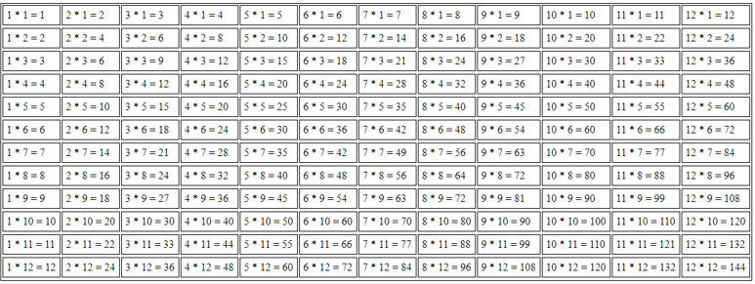

5-write a script that removes any duplicates from an array.

6- you have array of developers data:

[

[

'name' => 'ahmed hamdy',

'job' => 'front-end',

'experience' => 3

],

[

'name' => 'mohammed shaker',

'job' => 'back-end',

'experience' => 2

],

[

'name' => 'ali hasan',

'job' => 'full-stack',

'experience' => 4

],

];

write a script that displays data in bootstrap cards

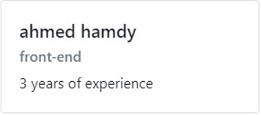

bootstrap card link:

<https://getbootstrap.com/docs/4.0/components/card/#titles-text-and-links>

7- trace the code & discuss of each statement of value of x and y

$x = 3 ; $y=$x++;

$y+= ++$x;

if ($y == 7) {

$x++;

echo $x ."<br>";

}

else if ($y == 8){

$x--;

echo $x ."<br>";

}

else if ($y == 9) {

$x+=2;

echo $x ."<br>";

}

else {

$x= 0;

echo $x ."<br>"; }